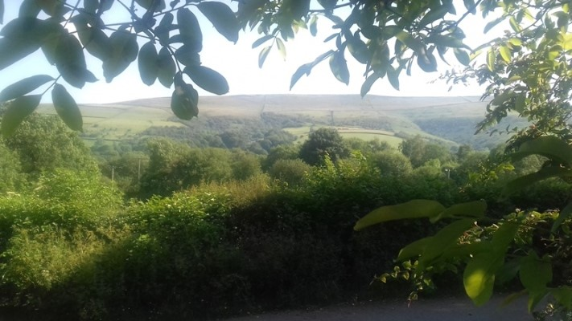
An Invitation to an
IPN Gathering Weekend
7-9th July 2023
Held at Bamford Quaker Community
IPN - accountability based on peer relationships for counsellors, psychotherapists, educators, growth workers and allied practitioners.
After the recent online gathering we are looking forward to being face-to-face again at Bamford in July. As we did last year, we want to use this time together for relationship building, sharing ways of working or discussing questions pertinent to practice. Please do think about offering a short activity or mini-workshop, or bring a topic for discussion to fuel our conversations throughout the weekend.
We would also like to create some space to continue the conversations started through the Zoom gathering; in particular co-creating:
- A concern/complaint process or framework that is relevant to the majority who are either individual participants or in forming groups
- A “starter pack” for new participant’s that helps them orientate themselves to participating within the Network…. a “how you can get involved & engage” guide.

Bamford offers a lovely environment with comfortable indoor space and beautiful green outdoor space both in the gardens as well as the wider Derbyshire countryside on the doorstep.

This is an ideal opportunity for people interested in participating in IPN to come along and meet existing participants and get a flavour of the network.

The meeting starts on Friday - arrive from 5pm, supper at 7pm, and closes at 2.00pm Sunday.

We will be self-catering and the kitchen is a VEGETARIAN ONLY space, so please bring food to share for two lunches and Saturday evening meal.

Remember: the gatherings are STILL FREE to all attendees so take advantage of this opportunity and book early to avoid disappointment.

Booking Form IPN Gathering Weekend
To be held at Bamford Quaker Community, Derbyshire.
www.quakercommunity.org.uk
Fri 7th July (arrive from 5pm, supper at 7pm)
to lunchtime Sunday 9th July 2023

The gathering weekend is free to attend. In cases of hardship we may be able to help with some travelling expenses. To do this, please contact the treasurer:
Gyan Tyagi email: tyagi@therapist.net

YOUR NAME:
ADDRESS:
POST CODE:
E-MAIL:
TEL: MOBILE:
In case of emergency during the gathering please contact …………………. Tel ……………
We will be self-catering, so please bring food to share for two lunches and Saturday evening meal. Note that the kitchen is vegetarian only.
Please underline as appropriate:
- I have the following dietary requirements: vegetarian; vegan; gluten free;
Other - please give details ……………………………………………
- I will be staying overnight: Friday & Saturday / Friday only / Saturday only / Neither
- I would like to camp (own tent) ….…………………
- If possible, I wish to share a room with the following attendee(s) ………………….
- Please take into account the following requirements/needs …………..….…………
- I am willing / not willing to share the above contact details with other attendees (e.g. for travel arrangements).
- I am willing to offer/would welcome a lift from ……….…………. to .……………..

Please complete and send this booking form to Susanne Wardle
Email: spillkrakase@gmail.com

